TRANSPORT IN HUMANS

The human transport system is a system of tubes with a pump and valves to ensure one way blood flow. We need a transport system to deliver oxygen, nutrients and other substances to all our body cells, and take away waste products from them.

The oxygenated blood (high in oxygen, red in color) comes to the heart from the lungs in the pulmonary vein; the heart pumps it to the aorta (an artery) to the rest of the body. The deoxygenated blood returns to the heart from the body in the vena cava (a vein), the heart pumps is to the lungs to get rid of the carbon dioxide.

Oxygenated Blood: Red color, high oxygen low Carbon dioxide.
Deoxygenated Blood: Blue color, low oxygen high Carbon dioxide.

Did you notice that during one circulation, the blood went through the heart twice, this is why we call it double circulation.

When the blood is flowing away from the heart, it has a very high pressure, when it is flowing towards the heart it has a lower pressure.

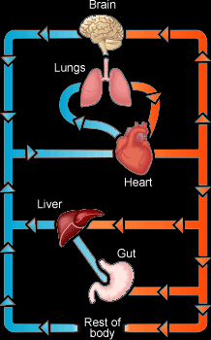

The Blood

The blood is a fluid consisting of several types of cells floating in a liquid called plasma.

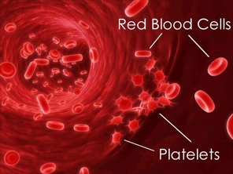

Red Blood Cells

These are one of the smallest cells in your body, they are round with a dent in the middle, we call this shape a Biconcave disc.

The function of the red blood cells is to transport oxygen from the lungs to the body cells. A red protein called Haemoglobin, when the blood reaches the lungs, oxygen diffuses from the alveoli to the red blood cells and combines with haemoglobin forming an unstable compound called oxyhaemoglobin. When the blood reaches the body cells, the oxyhaemoglobin is easily split into oxygen and haemoglobin again, the oxygen diffuses through the blood plasma to the cells.

Red blood cells are fully adapted to their function by the following characteristics:

- Biconcave disc shape gives it large surface area to carry more oxygen haemoglobin to combine with oxygen
- No nucleus that takes up space.

White Blood Cells

White blood cells are one of the substances floating in the blood plasma. They are completely different in function than red blood cells. White blood cells are part of the Immune System, they play a big role in protecting the body by killing bacteria which cause disease, also known as pathogens. White blood cells can be distinguished from red blood cells easily because they are much bigger, with a nucleus, and present in fewer amounts.

Types Of White Blood Cells:

Phagocytes:

They kill bacteria by engulfing them, taking them in the cell then kill them by digesting them using enzymes, this process is called phagocytosis.
Most white blood cells are the phagocyte type.

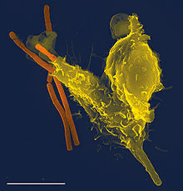

Lymphocytes:

Unlike phagocytes, lymphocytes have a large nucleus. They are produced in the lymph nodes (in the lymphatic system). Lymphocytes kill bacteria by secreting antibodies and antitoxins which kill the pathogens directly or make them easier to kill. Each pathogen could be killed by a certain type of antibody.

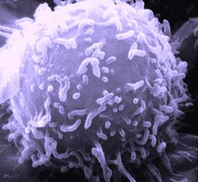

The Platelets

Platelets are tiny cell fragments that prevent bleeding when the skin is cut, and stops bacteria from entering our systems through the wound. This works by blood clotting, when the skin is cut, some reactions take place that results in platelets producing a protein, this protein will change the fibrinogen (another soluble protein in the plasma) to insoluble fibrin. The fibrin forms long fibres that clot together blocking the cut, thus preventing any bleeding, this is called blood clotting.

Blood Plasma

This makes up most of the blood. It is mostly water with some substances dissolved in it, these include carbon dioxide, hormones, food nutrients, urea and other waste products. The blood plasma transports substances from one place to another.

Functions of the blood

- Transportation of R.B.C’s, W.B.C’s, oxygen, food nutrients, hormones, and waste products.
- Defence against disease, by white blood cells phagocytosis and production of antibodies.
- Supplying cells with glucose to respire and keep a constant temperature.

Blood Vessels (Vascular System)
There are a number tubes carrying blood away from and to the heart and other organs. The main types are Arteries, Veins and Capillaries.

Arteries

Their function is to transport blood away from the heart to the lungs or other body organs.

The blood in the arteries always has a high pressure. The heart pumps the blood quickly into the arteries, resulting in the pressure, each time the ventricle of the heart contracts, the pressure in arteries increase, when the ventricle relaxes, the pressure falls. The lumen of arteries is also very narrow, adding to the pressure.

The structure is simple, beside the narrow lumen, the arteries have a strong thick wall to withstand the pressure. Their walls are also elastic and stretchable.

Brief description of characteristics of arteries:
- Transporting blood away from the heart
- Always in a high pressure
- Strong but stretchable walls
- Narrow lumen.

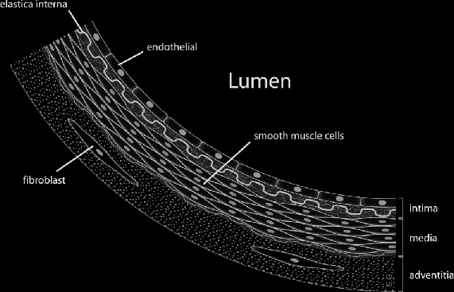

Veins

Their function is to transport blood to the heart from the body.

The veins always have a low blood pressure because by the time the blood with high pressure reaches the veins, it loses most of the pressure. This means that blood flows very slowly in veins, to help this, veins lie between muscles so that the blood is squeezed when the muscles contract.

They have a simple structure. Because they have a low pressure, they don’t need strong, thick walls like the artery, instead they have thin less elastic walls. Their lumen is much wider too. Veins have a unique feature, that is valves. Because blood in veins flows slowly with a low pressure, there is a risk of a backflow, specially in veins that move blood upwards against gravity, like the ones in the leg. The valves ensure that the blood is always flowing in the direction of the heart. When the muscles squeeze the blood, the valves are open the let blood through, when muscles relax, valves close to prevent a backflow.

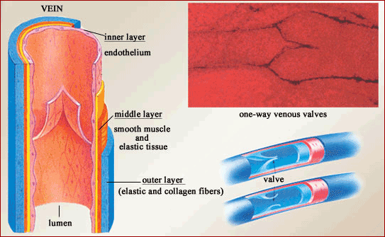

Brief description of characteristics of veins:

- They carry blood to the heart
- Always in a low pressure
- Thin less elastic walls
- Wide lumen
- Valves present.
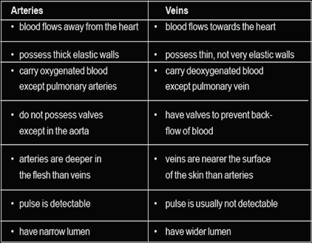

Blood Capillaries

Blood capillaries are the smallest blood vessels in our systems. Their function is to get blood from the arteries as close as possible to the tissues in order to exchange materials with the cells, and to link arteries with veins.

When arteries come near an organ or a tissue, it divides into arterioles, these arterioles divide more into several blood capillaries that go through the tissue, this is when the exchange of oxygen and food nutrients with carbon dioxide and waste products such as urea take place by diffusion.

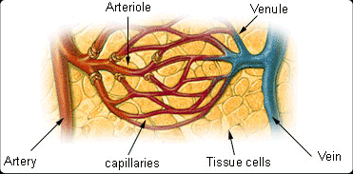

Blood capillaries are very well adapted to their jobs. They are one cell thick to reduce the diffusion distance of materials for faster diffusion. They also have pores in their walls between the cells, to allow the plasma to get out of the blood and become tissue fluid.

The Heart

The heart is a pumping organ that is responsible for the movement of blood around the body. The function of the heart is to give the blood a push, keeping it flowing around the body all the time. That is why the heart is constantly working, if it stops for a minute, the other organs will not receive any oxygen or nutrients, thus the body fails and the person dies. The heart is located in the chest, the thoriac cavity between both lungs.

Structure:

The heart is hollow, it has 4 chambers. Two of them are atria and two are ventricles. One of each of these on each side. When looking at the diagram of a heart, notice that your right is the left side of the heart, and your left is the heart’s right, as if you are looking at your own heart on a mirror.

The sides of the heart are separated by a wall called septum. Each side contains an atrium (at the top) and a ventricle (at the bottom), there is a valve between the atrium and the ventricle in each side, it is called bicuspid valve in the left side and tricuspid valve in the right side. There are several blood vessels associated with the heart, these are:

The Pulmonary vein, it transports oxygenated blood from the lungs to the right atrium.

The Aorta, which is the biggest artery in the body, it transports oxygenated blood from the heart to the rest of the body.

The Vena Cava, the biggest vein in the body, it transports deoxygenated blood from the whole body to the heart.

The pulmonary artery, it transports deoxygenated blood from the heart to the lungs.
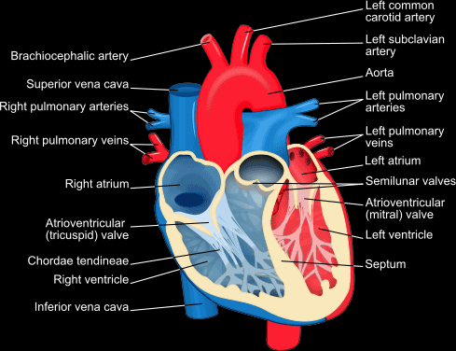

Note that blood vessels entering the heart are veins, and the ones leaving the heart are arteries. The left side of the heart always contains oxygenated blood because it receives blood fresh from the lungs and pumps it to the body, the right side always contains deoxygenated blood because it receives is from the body. You can memorise this by the word LORD:
Left Oxygenated – Right Deoxygenated

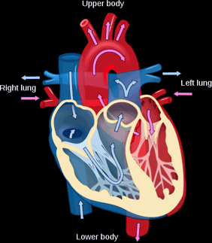

The heart receives blood from the lungs at the left atrium and pumps it to the body from the left ventricle, then it receives it again from the body at the right atrium and pumps it to the lungs from the right ventricle. The red shows oxygenated blood and the blue shows deoxygenated blood.

Notice that the walls around the left ventricle are much thicker than the ones in the right ventricle. The reason for this is that because the left ventricle pumps blood to the whole body, so blood will travel a long distance, so it needs lots of muscles to contract and pump the blood more strongly.

However, the right ventricle pumps blood the lungs which are very close to heart, the blood does not need to be pumped very strongly.

Mechanism of the heart:

When the heart is being filled with blood (whether from the body or the lungs), this is called the diastole. When the heart is pumping the blood out of it (whether to the body or to the lungs), it is called the systole.

During diastole, the heart is getting filled with blood, the blood enters the atria first, the atria contract to force blood into the ventricles, both tricuspid and bicuspid valves are open to allow blood into the ventricles and the semilunar valves are shut. Once the ventricles get filled with blood, it is systole, the bicuspid and tricuspid valves get shut and semilunar valves are open, the ventricles contract strongly forcing the blood into the Aorta or pulmonary artery.

During diastole the semilunar valves are shut to keep the blood out of the arteries. During systole the tricuspid and bicuspid valves are closed, to prevent blood from flowing back into the atria when it is pumped. The tricuspid and bicuspid valves are kept fixed by fibres called tendons, they prevent the valves from opening in the opposite direction, allowing backflow.

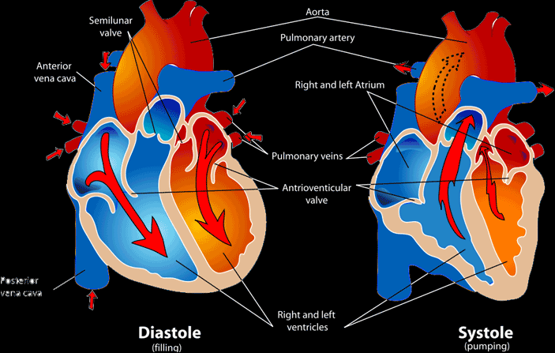

The tendons also control the opening and closing of the cuspid valves, when the tendons are loose, the valves are open. When the tendons are tightened the valves close.

 | Diastole | Systole
Ventricles: | Relax | Contract
Atria: | Contract | Relax
Cuspid Valves: | Open | Close
Tendons: | Loose | Tightened
Semilunar Valves: | Close | Open

If you listen to your heartbeat, you will hear two sounds, one low and one high. These are results of the systole and diastole. They are the sounds of the cardiac valves opening and shutting.

Coronary Heart Disease (CHD)

The heart, like any other organ, needs a supply of blood containing oxygen and nutrients. In fact, the heart needs a higher amount of blood supply than any other organ because it is working all the time, and contains a lot of muscles. The coronary arteries are those which supply the heart tissues with blood, they branch from the aorta. CHD develops when cholesterol layers build on the walls of the coronary arteries, partially blocking the path of blood, thus this tissue of the heart is not supplied with oxygen nor nutrients, so it stops working properly. If it is not treated at this age, a blood clot may form near the partially blocked area, completely blocking the artery, when this happens, the blood cannot function anymore, a heart attack occurs, which is extremely fatal.

The causes of CHD are mostly in the diet. A diet with lots of fats, increases the chance of cholesterol building up on the walls of the artery, causing CHD, Same thing with salts. Smoking also increases the rate of fat deposition. It was also said that Causes Of CHD are:

- Diet full of fats increases the fats level in blood
- Diet full of salts, salts can be deposited in the artery leading to CHD, same as fats or cholesterol
- Smoking, carbon monoxides increases fat deposition
- Stress is also said to contribute to CHD by raising blood pressure
- Lack of exercise, regular workouts improve the blood flow wearing layers of fats or salts deposited on the walls of arteries away.

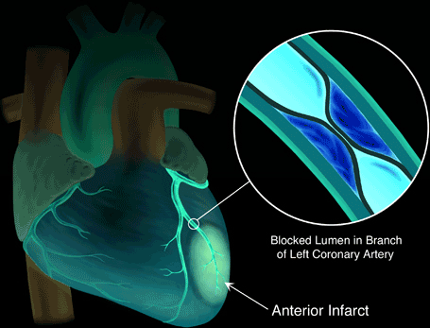
So to protect yourself from CHD you need to avoid diets full of fats and salts, avoid smoking, try to be less stressed out, and exercise regularly.

Tissue Fluid And Lymph

Tissue fluid is a fluid surrounding the cells of a tissue. It supplies them with all their needs of oxygen and nutrients, and takes away all their waste products including carbon dioxide. Tissue fluid plays a very big role in substance exchange between blood and cells.
Plasma from the blood capillaries move to the tissue through gaps in the walls. They become tissue fluid. They exchange their content of oxygen and nutrients with the cells and take carbon dioxide and waste products. At the end of the capillary bed, the tissue fluid leaks back into the blood, and becomes plasma again, but not all of it. A little of it is absorbed by the lymphatic vessel and becomes lymph. The lymphatic vessel takes the lymph to the blood stream by secreting them in a vein near the heart, called subclavian vein. The lymph in the lymphatic vessels are moved along by the squeeze of muscles against the vessel, just like some veins.

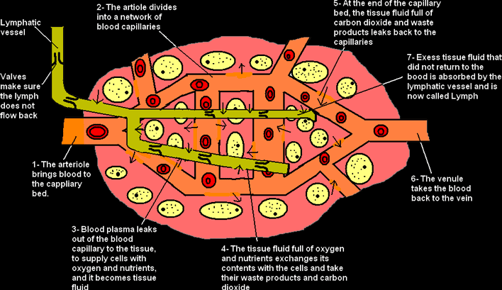

The lymphatic system plays a big role in the protection against disease. It produces the white blood cells lymphocytes. Which kill any cell with a different antigens than the ones in your body cells. So if bacteria get into your body, your lymphocytes quickly recognise them as foreigners and will divide and kill them.
Lymphocytes are considered a problem when it comes to organs transplant. For example if someone (recipient) with renal failure receives a kidney from another person (the donor), the cells of the kidney will have different antigens than the other cells in the patient’s body. The lymphocytes will consider the cells of the kidney an enemy and start attacking it, this is called tissue rejection. Organ transplant is perfect in one case, this is when the donor and the recipient are identical twins, because the antigens of their cells perfectly match. In other cases the recipient is given immunosuppressant drugs to actually weaken their immune system to prevent tissue rejection.

Brief Summary Of Functions Of The Lymphatic System:

- Production of white blood cells lymphocytes
- Transport of digested fats from villi to blood stream
- Transport of lymph from the tissue fluids to the blood stream at the subclavian vein.

